SOFTWARE REQUIREMENTS SPECIFICATION

**For**

**E-Learning Management System**

**Prepared by:-**

*Yuvaraj D*

*Atchaya E S*

*Pavithra P*

*Dhanushya M*

# Introduction

## Purpose

An E-Learning Management System (LMS) is a software application that helps organizations create, deliver, manage, and track online learning experiences. It's essentially a virtual classroom where instructors can upload course materials, learners can access and complete assignments, and administrators can track progress and performance.

## Document Conventions

* + - Entire document should be justified.
    - Convention for Main title

Font face: Times New Roman Font style: Bold

Font Size: 14

* + - Convention for Sub title

Font face: Times New Roman Font style: Bold

Font Size: 12

* + - Convention for body

Font face: Times New Roman Font Size: 12

## Scope of Development Project

## The E-learning Management System (LMS) market is booming, and with good reason. As technology advances and the demand for online learning grows, the scope for development in LMS platforms is vast and exciting. Here are some key areas where we can expect to see significant progress:

1. Artificial Intelligence (AI) and Machine Learning (ML):
2. Gamification and Immersive Technologies
3. Big Data and Learning Analytics
4. Blockchain and Secure Learning
5. Social Learning and Collaboration

* 1. **Definitions, Acronyms and Abbreviations**

**LMS: Learning Management System**

**ELMS: Electronic Learning Management System**

**LCMS: Learning Content Management System**

**VLE: Virtual Learning Environment**

**LXP: Learning Experience Platform**

## References

* + - Books

1. "E-Learning by Design" by William Horton
2. "Learning Management System Technologies and Software Solutions for Online Teaching" by Fawzi Albalooshi
3. "SQL Performance Explained" by Markus Winand
   * + Websites
4. <https://theelearningcoach.com/>
5. https://elearningindustry.com/

# Overall Descriptions

## Product Perspective

## Use Case Diagram for Online Learning System

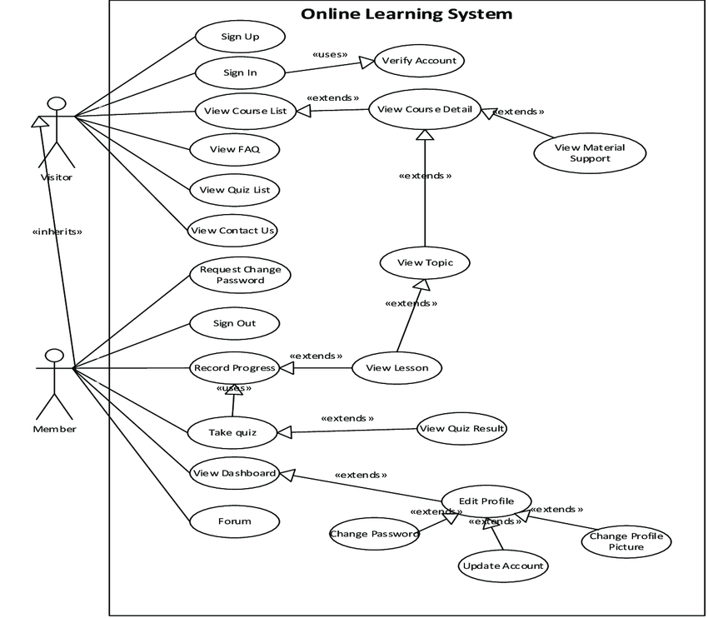

This is a broad level diagram of the project showing a basic overview. The visiter or member can

be either staff or student.Admins can add courses in a particular subject and students can enroll

Courses and study them, and also students can message other participants in a particular course

Except the teacher teaching that course.

## Product Function

Entity Relationship Diagram of Online Course learning management system

online course learning management system provides online real time information about the courses available in the platform and its information. The main purpose of this project is to reduce the manual work. This project aims at serving Students and Teachers in online based learning.Admins can add subjects,Teachers can add courses in a particular subject and Students can enroll courses and study them,and also Students can message other participants in a particular course except the teacher teaching that course.

## User Classes and Characteristics

The system provides different types of services based on the type of users [student/teacher]. The Admin will be acting as the controller and he will have all the privileges of an administrator. The student/teacher of the university will have access to the course online.

The features that are available to the Teacher are:-

* + - A Teacher can issue a course to the student.
    - Can view the different categories of courses available in the platform.
    - Can view the List of courses available in each category.
    - Can view students count in particular course.
    - Can Edit the information of existing course.
    - Can check the report of the existing course.

The features that are available to the Students are:-

* + - Can view the different categories of courses available in the platform.
    - Can view the List of courses available in each category.
    - Can own an account in the platform.
    - Can view the course enrolled by him.
    - Can make a request for a new course.
    - Can view the history of courses enrolled by him previously.
    - Can search for a particular course.

## Operating Environment

## Cloud-based: Cloud-based LMSs are hosted by a third-party provider and are accessed through a web browser. This eliminates the need for organizations to install and maintain LMS software on their own servers. Cloud-based LMSs are typically scalable and flexible, making them a good option for organizations of all sizes.

## On-premises: On-premises LMSs are installed and maintained on an organization's own servers. This gives organizations more control over their LMS, but it also requires more IT resources. On-premises LMSs are typically a good option for organizations with large IT departments or specific security requirements.

## Open source: Open source LMSs are available for free and can be customized by organizations to meet their specific needs. Open source LMSs are typically a good option for organizations with limited budgets or specific requirements.

## Assumptions and Dependencies

The assumptions are:-

* Learner tech literacy: Learners have basic computer skills, internet access, and familiarity with using web applications.
* Institutional support: The organization implementing the LMS has the infrastructure, resources, and personnel to support its deployment and maintenance.
* Clear learning goals and objectives: Courses developed within the LMS have well-defined learning objectives and are aligned with the organization's overall training goals.
* Content quality: Learning materials uploaded to the LMS are accurate, engaging, and pedagogically sound.

The dependencies are:-

* Reliable internet connection: Both learners and administrators need consistent access to the internet to use the LMS effectively.
* Compatible devices and browsers: The LMS should be accessible on various devices and compatible with popular web browsers to ensure learner accessibility.
* Technical support: The LMS provider offers ongoing technical support to address any system issues or user queries.
* Data security and privacy: The LMS platform implements robust security measures to protect learner data and ensure compliance with privacy regulations.
* Integration with other systems: The LMS can integrate with existing enterprise systems like HR, learning record stores, and student information systems for seamless data flow and improved user experience Library System
* Any update regarding the book from the library is to be recorded to the database and the data entered should be correct

## Requirement

Software Configuration:-

This software package is developed using java as front end which is supported by sun micro system. Microsoft SQL Server as the back end to store the database.

1. Windows Operating System.
2. JRE and JDK.
3. MySQL server(WAMP).

Hardware Configuration:-

1. Computer with either Intel Pentium processor or AMD processor
2. 1GB+ DDR RAM
3. 40GB hard disk drive.

## Data Requirement

The inputs consist of the query to the database and the output consists of the solutions for the query. The output also includes the user receiving the details of their accounts. In this project the inputs will be the queries as fired by the users like create an account, selecting course and putting into account. Now the output will be visible when the user requests the server to get details of their account in the form of time, date and which couses are currently enrolled in the account.

# External Interface Requirement

* External interfaces play a crucial role in enabling an e-learning management system (LMS) to connect with other systems, share data, and streamline workflows. These interfaces facilitate integrations that extend the capabilities of the LMS and enhance its usefulness within an organization's ecosystem.
* The specific external interface requirements of an LMS will vary depending on the organization's needs and the types of systems they use. However, some common external interfaces that are considered essential for a comprehensive LMS include:
* Student Information System (SIS) Integration: This interface allows the LMS to exchange data with the organization's SIS, enabling seamless synchronization of student enrollment, profile information, and academic records.
* Learning Content Management System (LCMS) Integration: This interface enables the LMS to connect with an LCMS, allowing for the transfer of learning content and metadata. This integration streamlines the creation, management, and deployment of high-quality learning materials.
* Third-party Tools Integration: This interface allows the LMS to integrate with various third-party tools, such as authoring tools, assessment platforms, and collaboration software. This integration expands the range of tools and functionalities available to instructors and learners.
* Single Sign-On (SSO) Integration: This interface facilitates SSO, allowing users to authenticate once and access the LMS and other integrated systems without repeatedly entering their credentials. This enhances user convenience and security.
* APIs and Web Services: The LMS should provide APIs (Application Programming Interfaces) and web services to enable custom integrations with other systems. This flexibility allows organizations to tailor the LMS to their specific requirements and workflows.

In addition to these common external interfaces, LMSs may also integrate with systems specific to the organization's industry or needs, such as HRMS (Human Resource Management System) for employee training, CRM (Customer Relationship Management) for sales training, or LMSs within a larger LMS ecosystem for managing multiple training domains.

# System Features

# E-learning management systems (LMS) are software applications used to manage and deliver online learning programs.

# LMSs offer a wide range of features to support course management, assessment management, learner engagement, reporting and analytics, and system administration

# When selecting an LMS, organizations should consider their specific needs, budget, and technical capabilities.

# Other Non-functional Requirements

## Performance Requirement

## Responsiveness and speed: Pages should load quickly, especially for learners on low-bandwidth connections. A laggy LMS can kill motivation.

## Scalability and stability: The system should handle multiple users and concurrent access without crashes, even during peak learning hours.

## Content delivery reliability: Videos, simulations, and other learning materials should play smoothly and consistently without buffering or errors.

## Reporting and analytics: Data should be available in real-time or near real-time to track learner progress, identify bottlenecks, and measure overall LMS effectiveness

## Safety Requirement

## Safety Requirements for E-learning Management Systems

## Protect learner data with strong encryption, access controls, and regular security audits.

## Implement robust access control mechanisms to restrict unauthorized access to data, content, and system settings.

## Keep the LMS software up-to-date with the latest security patches and updates.

## Regularly scan the LMS for vulnerabilities to identify and remediate potential security weaknesses.

## Provide regular cybersecurity training to LMS administrators and authorized personnel.

## Secure data exchanged between the LMS and third-party tools or services.

## Regularly review and update safety requirements as technology evolves and threats change.

## Security Requirement

* + - System will use secured database
    - Normal users can just read information but they cannot edit or modify anything except their personal and some other information.
    - System will have different types of users and every user has access constraints
    - Proper user authentication should be provided
    - No one should be able to hack users’ password
    - There should be separate accounts for admin and members such that no member can access the database and only admin has the rights to update the database.

## Requirement attributes

* + - There may be multiple admins creating the project, all of them will have the right to create changes to the system. But the members or other users cannot do changes
    - The project should be open source
    - The Quality of the database is maintained in such a way so that it can be very user friendly to all the users of the database
    - The user be able to easily download and install the system

## Business Rules

A business rule is anything that captures and implements business policies and practices. A rule can enforce business policy, make a decision, or infer new data from existing data.This includes the rules and regulations that the System users should abide by. This includes the cost of the project and the discount offers provided. The users should avoid illegal rules and protocols. Neither admin nor member should cross the rules and regulations.

## User Requirement

The users of the system are Students and Teachers of the university who act as members to maintain the system. The members are assumed to have basic knowledge of the computers and internet browsing. The administrators of the system should have more knowledge of the internals of the system and is able to rectify the small problems that may arise due to disk crashes, power failures and other catastrophes to maintain the system. The proper user interface, user manual, online help and the guide to install and maintain the system must be sufficient to educate the users on how to use the system without any problems.

The admin provides certain facilities to the users in the form of:-

* + - Backup and Recovery
    - Forgot Password
    - Data migration i.e. whenever user registers for the first time then the data is stored in the server
    - Data replication i.e. if the data is lost in one branch, it is still stored with the server
    - Auto Recovery i.e. frequently auto saving the information
    - Maintaining files i.e. File Organization
    - The server must be maintained regularly and it has to be updated from time to time

# Other Requirements

## Data and Category Requirement

There are different categories of users namely teaching staff, Admin, students etc. Depending upon the category of user the access rights are decided.It means if the user is an administrator then he can be able to modify the data,delete, append etc. Admin only have the rights to retrieve the information about database. Similarly there will be different categories of courses available. According to the categories of courses their relevant data should be displayed. The categories and the data related to each category should be coded in the particular format.

## Appendix

A: Admin, Abbreviation, Acronym, Assumptions; B: Business rules; C: Class, Client, Conventions; D: Data requirement, Dependencies; G: GUI; K: Key; L: Library, Librarian; M: Member; N: Non-functional Requirement; O: Operating environment; P: Performance,Perspective,Purpose; R: Requirement, Requirement attributes; S: Safety, Scope, Security, System features,Student; T:Teacher; U: User, User class and characteristics, User requirement;

## Glossary

The following are the list of conventions and acronyms used in this document and the project as well:

* + - Administrator: A login id representing a user with user administration privileges to the software
    - User: A general login id assigned to most users
    - Client: Intended users for the software
    - SQL: Structured Query Language; used to retrieve information from a database
    - SQL Server: A server used to store data in an organized format
    - Layer: Represents a section of the project
    - User Interface Layer: The section of the assignment referring to what the user interacts with directly
    - Application Logic Layer: The section of the assignment referring to the Web Server. This is where all computations are completed
    - Data Storage Layer: The section of the assignment referring to where all data is recorded
    - Use Case: A broad level diagram of the project showing a basic overview
    - Class diagram: It is a type of static structure diagram that describes the structure of a system by showing the system’s cases, their attributes, and the relationships between the classes
    - Interface: Something used to communicate across different mediums
    - Unique Key: Used to differentiate entries in a database

## Class Diagram

A class is an abstract, user-defined description of a type of data. It identifies the attributes of the data and the operations that can be performed on instances (i.e. objects) of the data. A class of data has a name, a set of attributes that describes its characteristics, and a set of operations that can be performed on the objects of that class. The classes’ structure and their relationships to each other frozen in time represent the static model. In this project there are certain main classes

which are related to other classes required for their working. There are different kinds of relationships between the classes as shown in the diagram like normal association,aggregation, and generalization. The relationships are depicted using a role name and multiplicities. Here ‘Course Administrator’, ‘Student’ and ‘Tutor’ are the most important classes which are related to other classesA diagram of a course
